**Drohobych Ivan Franko State Pedagogical University**

**English Language and Translation Studies Department**

**Yuliya Talalay**

**PRACTICAL ENGLISH LANGUAGE COURSE:**

**materials for self-study: a textbook for Master’s Degree students (Term 2)**

**Drohobych**

**2025**

**Дрогобицький державний педагогічний університет**

**імені Івана Франка**

**кафедра англійської мови та перекладу**

**Талалай Юлія**

**ПРАКТИЧНИЙ КУРС АНГЛІЙСЬКОЇ МОВИ:**

**матеріали для самостійного опрацювання :** навчальний посібник для студентів другого магістерського рівня вищої освіти (2 семестр)

**Дрогобич,2025**

**УДК 811.111‛24 (076)**  
**Т16**

*Рекомендовано вченою радою Дрогобицького державного  
педагогічного університету імені Івана Франка  
(протокол № 3 від 26 березня 2025 року)*

**Рецензенти:**

**Сирко І. М.**, кандидат філологічних наук, доцент кафедри практики англійської мови та методики її навчання факультету української та іноземної філології Дрогобицького державного педагогічного університету імені Івана Франка;

**Яскевич О. К.,** кандидат філологічних наук, доцент кафедри англійської мови та перекладу факультету української та іноземної філології Дрогобицького державного педагогічного університету імені Івана Франка.

**Відповідальна за випуск –**

**Сліпецька В. Д.,** кандидат філологічних наук, доцент, завідувач кафедри практики англійської мови та методики її навчання факультету української та іноземної філології Дрогобицького державного педагогічного університету імені Івана Франка.

**Талалай Ю. О.**

**Практичний курс англійської мови** : матеріали для самостійного опрацювання**:** навчальний посібник для студентів другого магістерського рівня вищої освіти (2 семестр). Дрогобич : Дрогобицький державний педагогічний університет імені Івана Франка, 2025. 60 с.

Зміст матеріалів для самостійного опрацювання відповідає програмі навчальної дисципліни «**Практичний курс англійської мови»**, складеної на основі програмних результатів навчання, визначених в освітній програмі «Середня освіта (Мова і література (німецька; англійська)) другого (магістерського) рівня вищої освіти спеціальності «014 Середня освіта (Мова та література (Німецька мова та література)) галузі знань «01 Освіта / Педагогіка» галузь знань 01 Освіта / Педагогіка. У ньому представлені матеріали та завдання для перевірки сприйняття змісту прочитаного та засвоєння вивченого вокабуляру, тексти для читання і аналізу, вправи, спрямовані на закріплення знань зі словотвору, речення українською мовою для перекладу англійською, граматичні вправи, завдання на пошук слів.

Посібник також містить відеосекцію з метою закріплення навичок слухання та розвитку навичок письма (короткі відповіді на базі відео). Для закріплення навичок письма запропоновані теми для написання есе, листів, статей, теми для перевірки навичок говоріння.

**ЗМІСТ / CONTENTS**

|  |  |
| --- | --- |
| ПЕРЕДМОВА…………………………………………………………… | 5 |
| PREFACE………………………………………………………………… | 6 |
| UNIT 1 MUSIC &amp; EMOTION / РОЗДІЛ 1 МУЗИКА ТА  ЕМОЦІЇ…………………………………………………………………… | 7 |
| UNIT 2 DON’T ARGUE! ARGUMENTS AND SOLUTIONS. THE BEST WAYS TO WIN AN ARGUMENT / НЕ КОНФЛІКТУЙ! АРГУМЕНТИ І ВРЕГУЛЮВАННЯ КОНФЛІКТНИХ СИТУАЦІЙ. НАЙКРАЩІ СПОСОБИ ЯК ПЕРЕМОГТИ В СУПЕРЕЧЦІ………….. | 18 |
| UNIT 3 ACTORS ACTING / АКТОРСЬКА ГРА………………………. | 29 |
| GRAMMAR / ГРАМАТИКА……………………………………………. | 38 |
| VIDEOS / ВІДЕО………………………………………………………… | 48 |
| WORDSEARCH / ПОШУК СЛІВ………………………………………. | 56 |
| REFERENCES / СПИСОК ВИКОРИСТАНОЇ ЛІТЕРАТУРИ………... | 59 |

**ПЕРЕДМОВА**

У посібнику подається матеріал для засвоєння тем «Музика та Емоції», «Не конфліктуй! Аргументи та врегулювання конфліктних ситуацій. Найкращі способи як перемогти в суперечці», «Акторська гра». У роботі підібрано низку текстів для читання та завдання на перевірку сприйняття змісту прочитаного, лексичні одиниці до кожної підтеми, включаючи фразові дієслова, ідіоматичні вирази, сталі словосполучення, похідні форми слів, синоніми й антоніми. У посібнику презентується система вправ тренувального характеру для кращого засвоєння матеріалу та відтворення його на практиці. Посібник присвячений розвитку навичок читання, аудіювання, мовлення та письма; вмінь студентів аналізувати і вести обговорення, використовуючи новий тематичний словниковий запас і виокремлені граматичні структури. Окрім засвоєння поданого матеріалу та збагачення лексичного запасу студентів, методичний посібник містить завдання, що формують у них здатність логічно мислити, висловлювати власну думку щодо прочитаного, допомагають засвоїти різні методи самостійної роботи.

**PREFACE**

The study guide provides material for aaccruing knowledge on the topics “Music and Emotion”, “Don’t Argue! Arguments and Solutions. The Best Way to Win an Argument”, “Actors Acting”. The textbook includes a number of texts for reading and tasks for checking the perception of the content of what was read, lexical units for each subtopic, including phrasal verbs, idiomatic expressions, fixed phrases, derivative forms of words, synonyms and antonyms. The textbook consists of a system of training exercises in order to keep in mind the material and its practical usage. The textbook is aimed at the development of reading, listening, speaking and writing skills; students’ ability to analyze and conduct discussions using new thematic vocabulary and selected grammatical structures. In addition to assimilating the given material and enriching students’ vocabulary, the methodological textbook includes tasks that form students’ ability to think logically, express their own opinion about what they have read, and help students learn various methods of independent work.

**Unit 1 Music & emotion**

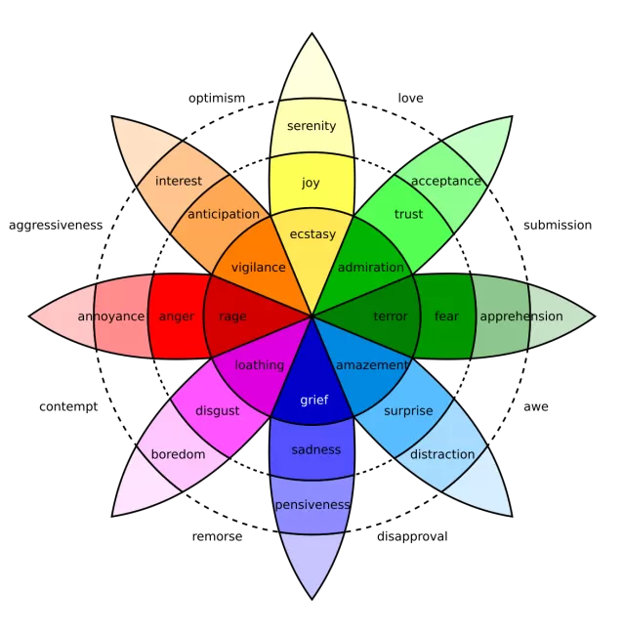

**Speaking Skills**

1. *Look at the picture above. Do you know the translation of every single word?*
2. *Have you ever felt serenity/disgust/fear/amazement? Could you share your own experience?*
3. *How do you take care of your mental health?*
4. *What kind of music helps you to manage anxiety/stress?*
5. *Do you consider yourself to be a music junkie? Why? Why not?*

**Reading**

**2. Read the text “Understanding Emotions: A Guide for B2 Learners”. Make up headings for each passage.**

Emotions are a natural part of being human. They are feelings that we experience in response to different situations, events, or thoughts. Understanding emotions is important because they affect the way we think, behave, and interact with others. In this text, we will explore some common emotions and how they influence our lives.

**______________** Emotions are complex reactions that involve our mind, body, and behavior. When we feel happy, sad, angry, or afraid, our body might change. For example, when we are excited, our heart may beat faster, and when we are scared, we might feel nervous or tense. Emotions can also affect our thoughts. When we are in a good mood, we tend to think more positively. On the other hand, when we are sad or angry, we may focus on negative thoughts.

**______________**

1. **Happiness:** This is one of the most positive emotions. People feel happy when they experience good things, like spending time with friends, receiving good news, or achieving a goal. Happiness can make us feel relaxed, energetic, and optimistic.
2. **Sadness:** Sadness is a normal emotion that everyone experiences at some point. It can happen when we lose something important, face disappointment, or experience failure. While sadness is not pleasant, it is part of life, and it can help us reflect on what is important to us.
3. **Anger:** Anger is a strong emotion that happens when we feel hurt, frustrated, or treated unfairly. Sometimes, anger can motivate us to make changes or stand up for ourselves. However, it is important to manage anger carefully, as it can cause problems if it is not expressed in a healthy way.
4. **Fear:** Fear is an emotion that helps protect us. It happens when we face a dangerous or unknown situation. For example, we may feel afraid when we hear a loud noise or when we are in an unfamiliar place. Fear can help us avoid dangerous situations, but sometimes it can be too strong, even when there is no real threat.
5. **Surprise:** Surprise happens when something unexpected occurs. It can be a positive surprise, like a birthday gift, or a negative one, like hearing bad news. The feeling of surprise is often temporary, but it can be strong and cause us to react quickly.
6. **Disgust:** Disgust is a feeling of strong dislike or revulsion. It can happen when we see something unpleasant, like spoiled food or something dirty. Disgust is a way of protecting ourselves from things that might be harmful.

**________________** Emotions help us understand what is happening around us and how we feel about it. They guide our decisions and influence how we react to situations. For example, if we feel fear in a dangerous situation, we might choose to escape or protect ourselves. If we feel happy, we might want to share that feeling with others.Emotions also help us build relationships. When we understand our own emotions and the emotions of others, we can communicate better and show empathy. Being aware of emotions helps us respond in ways that are respectful and caring.

**__________________** It is important to manage emotions in a healthy way. Sometimes, we may feel overwhelmed by our emotions, but there are ways to handle them. Here are some strategies:

* **Take a deep breath:** If you are feeling angry or anxious, taking a few deep breaths can help calm your mind and body.
* **Talk about your feelings:** Talking to a friend or family member can help you understand your emotions and feel supported.
* **Exercise:** Physical activity, like going for a walk or doing sports, can reduce stress and help you feel better.
* **Think positive thoughts:** When you are feeling sad or frustrated, try to focus on things that make you feel good.

_______________ Emotions are a normal and important part of our daily lives. By understanding and managing our emotions, we can improve our well-being and have better relationships with others. Remember that all emotions, both positive and negative, are a natural part of the human experience, and it’s okay to feel them. The key is learning how to respond to them in a healthy and productive way.

**Listening**

**3. Listen to five people talking about memory and choose the things that are mentioned.**

* a job they had
* a type of animal
* a holiday
* a piece of music
* a childhood event
* the name of a book
* some singer

**Language Focus: Vocabulary Practice**

**4. Provide English definitions and make sentences with the following idioms:**

*To be a happy camper –*

*To be tickled pink –*

*To paint the town red –*

*To be in a stew –*

*To have a lump in one’s throat –*

*To get cold feet –*

*To be on the fence –*

*To keep stiff upper lip –*

*To fly off the handle –*

*To be shaken up –*

**5. Match two columns in order to make collocations/compound words:**

**mind stopping**

**go my head**

**heart junkie**

**to be taken boggling**

**music emotion**

**depth/intensity of in**

**scratching against all my rules**

**6. Word-building. Fill in the box. You will have to make a new part of speech, as in the example:**

|  |  |  |
| --- | --- | --- |
| ***to imagine*** | ***Imagination*** | ***(un)imaginative*** |
| to deceive |  |  |
| to convince |  |  |
| to illusion |  |  |
| to explain |  |  |

**7. Complete the sentences with the words in the bold.**

**UNREAL / UNREALISTIC**

1. **a.** I felt really _____________ to be watching my childhood hero on the stage at last.

**b.** It’s _____________ to think that a trainee magician could perform such illusions so soon.

**UNIMAGINABLE / UNIMAGINATIVE**

1. **a.** The examiner was disappointed that so many of the submissions were _____________.

**b.** The number of people involved in creating the special effects was _____________.

**ILLUSORY / DISILLUSIONED**

1. **a.** The performer was _____________ by the reception to his show and cancelled the tour.

**b.** The effect of fire was _____________, created by clever lighting.

**DECEPTION / DECEIT**

1. **a.** The article uncovered the celebrity’s _____________ about the charities he claimed to have contributed to.

**b.** The conjuror’s _____________ was so clever that no one realized how he performed the trick.

**EXPLANATORY / INEXPLICABLE**

1. **a.** There were some _____________ notes on the tricks at the back of the book.

**b.** For me it is _____________ how the trick took in so many people [2]

**Reading + Writing**

**8.Read the text and answer the questions.**

The British music industry is to sue 28 internet users it says are illegally swapping music online. The British Phonographic Industry (BPI) says it is targeting “major uploaders” – those who make music available to share free with others. Music file-sharers have been blamed for a decline in world-wide CD sales. The BPI’s actions follow that of its US counterpart which is already suing those it calls the worst offenders. It says more cases are expected to come. A further 459 alleged file-sharers across Europe now face legal action, the IFPI global music industry body said on Thursday, with France and Austria also targeted for the first time. US record companies have issued more than 5,700 lawsuits from alleged file-sharers, with many settling out of court. At the moment the BPI does not know the names of the 28 people it is going after, but is asking the courts to force internet service providers to hand over their personal information.

There was an outcry when a 12-year-old girl from New York was served with a lawsuit by the US industry, which was eventually settled by her mother. The same could yet happen in the UK. “We don’t screen for political correctness. We go on the basis of IPaddresses. We do not know who it is, it is based on their internet activity,” said IFPI chairman Jay Berman. IP addresses are used to identify a particular machine using the internet at any one time.

BPI chairman Peter Jamieson said: “We have been warning for months that unauthorised file-sharing is illegal. These are not people casually downloading the odd track. “They are uploading music on a massive scale, effectively stealing the livelihoods of thousands of artists and the people who invest in them.”

The 28 people being sued in the UK should find out in the coming few weeks who they are, said BPI general counsel Geoff Taylor. Once they have been served with the legal action they will be given the chance to settle out of court. If they do not the BPI will seek damages and an injunction to stop them using file-sharing services.

The BPI believes a hardcore 15% of file-sharers are responsible for 75% of all illegal music downloading [5].

1. **What effect has music downloading had on the the music industry?**

* it has led to a decline in sales
* very little, it is only a few people
* it has led to an increase in music sales.

**2. Who is the industry most concerned about?**

* those, who download songs
* those, who upload songs
* the singers

1. **What does the article say about the music file-sharers?**

* most are casual downloaders
* there are 28 of them in Europe
* they are stealing from musicians [5].

**9.Write a short review based on the text in ex. 7. What’s your attitude towards illegal downloading and file sharing? Your answer should written in 90 – 150 words.**

**10. Write an essay on the following topic: “Has music influence on your mood?” Share your own experience.**

**11. Translate into English:**

1. Почуття та емоції — це важливі складові **людської природи**, які формують наше **сприйняття світу**, **взаємодію з іншими людьми** та навіть впливають на наше **самопочуття.**
2. Серце **наповнилося безмежною радістю**, коли я побачив **усмішки “від вуха до вуха”** на обличчях моїх близьких. Ми **були на 7 небі від щастя.**
3. Джил – **справжній меломан!** Ти бачила її колекцію дисків?
4. **Тимчасова тиша**, що огорнула кімнату Джил, несла в собі **тяжкий сум** — відчуття, яке важко було виразити словами, але яке **гнітило серце**. Вона **розійшлась** з ним. Джил ще **не звикла** до відчуття **самотності**. Саме тому, її друзі запропонували **піти в загул**.
5. Маленькій Люсікожен крок в темному лісі здавався занадто гучним, а **серце билося** так, ніби воно ось-ось **вистрибне з грудей**. Ох і **даремно** вона **ослухалась** батьків та пішла грати в хованки. Люсі **була шокована та засмучена** (ідіома).
6. Я **не міг повірити своїм очам**: переді мною розгорнулася картина, що відразу **вразила і зачарувала** – таке **чудо** я не міг навіть уявити. — Це ти розповідаєш про своє “**підкорення” гори** Пікуй? — Саме так! Це незабутній досвід!
7. Кожен погляд на її обличчя **запалював у мені безмежну любов**, немов **маленький вогник**, що поступово **розгоряється в палаючий вогонь**, охоплюючи всі думки і почуття. Я **не міг відвести від неї погляд**.
8. Наш новий керівник **спалахує як “сірник”.** Тому, моя дружня порада – виконай це завдання якісно та вчасно. В іншому випадку – тебе **висварять та оголошуть догану.**
9. Тобі доведеться **подивитись правді в очі.** На жаль, твій син не **має музичного слуху.**
10. Хто **грає лідируючу роль у цій компанії?**

**EXTRA PRACTICE ACTIVITIES**

1. **Mindful Listening Exercise. Goal:** Develop active listening skills and emotional empathy.

* **Instructions:**
  1. Pair up participants. One person will speak about a challenging emotional experience they recently had, while the other person listens attentively without interrupting.
  2. The listener should focus on understanding the speaker’s feelings, maintaining eye contact, and nodding to show empathy.
  3. After 3-5 minutes, the listener should reflect back what they heard, focusing on emotions and needs (e.g., “It sounds like you felt frustrated when that happened, and you really needed more support from your team”).
  4. Switch roles and repeat the exercise.

**Discussion Prompt:** *How did it feel to be truly listened to? How did this help you understand your own emotions or the other person’s emotions better?*

**13.Creating an Emotion Management Plan. Goal:** Develop a personalized strategy for handling difficult emotions.

* **Instructions:**
  1. Ask participants to think about a specific emotion they often struggle with (e.g., anger, stress, anxiety).
  2. Create an “Emotion Management Plan” by answering the following questions:
     + What triggers this emotion?
     + How do I usually react when I experience this emotion?
     + What are healthier coping strategies I can try (e.g., deep breathing, physical activity.

**14.Write a proposal. You are the active member on campus, who decided to implement musical pauses on the breaks. You were asked to submit a proposal outlining some ideas about the music genres / duration etc.**

**15. “The Influence of Social Media on Popular Music Trends”. Analyze how platforms like YouTube, Instagram, and TikTok shape the music industry and influence the types of music people listen to.**

**Unit 2 don’t argue! arguments and solutions. the best ways to win an argument**



**Speaking Skills**

1. *Describe the picture, which is above. Guess where are the people / what are they?*
2. *Ponder over the idea, which is the stumbling for the people.*
3. *What kind of impression do you get when looking at the picture? Explain in simple terms.*

**Reading + Quiz**

**2. Complete the quiz and discuss your point of views:**

**1. What is the most important factor in winning an argument?**

A) Having a loud voice

B) Knowing your facts and evidence

C) Getting the other person to agree with you immediately

D) Interrupting the other person when they speak

**2. Which of the following is an effective strategy to use when arguing?**

A) Name-calling and personal attacks

B) Staying calm and composed

C) Changing the subject to avoid losing

D) Yelling louder than the other person

**3. When trying to persuade someone, which approach is generally most successful?**

A) Focusing only on your perspective

B) Listening actively to understand their point of view

C) Dismissing their ideas without explanation

D) Using sarcasm to weaken their argument

**4. What is the benefit of using evidence during an argument?**

A) It shows that you have knowledge on the topic

B) It makes the other person feel attacked

C) It confuses the other person

D) It allows you to dominate the conversation

**5. Which of the following is a tactic that should be avoided in order to win an argument?**

A) Asking clarifying questions

B) Making generalizations or assumptions without evidence

C) Staying focused on the issue at hand

D) Acknowledging when the other person has made a good point

**6. How can you show respect for the other person's opinion during an argument?**

A) By agreeing with everything they say

B) By telling them they’re wrong without offering an explanation

C) By acknowledging their perspective before presenting your own

D) By constantly interrupting to make your point

**7. What is the role of emotional control in an argument?**

A) Emotional control isn’t important as long as you make your point

B) It helps you stay rational and prevents the argument from escalating into a personal conflict

C) It allows you to manipulate the other person

D) Emotional control makes you appear weak

**8. Why is it important to stay focused on the main issue during an argument?**

A) It ensures you don’t get distracted by irrelevant points

B) It allows you to change the topic whenever you're losing

C) It lets you bring up unrelated facts to confuse the other person

D) It helps you avoid listening to their arguments

**9. Which of the following can be used as a helpful technique for ending an argument?**

A) Storming off to avoid further discussion

B) Making the other person feel guilty for disagreeing

C) Summarizing the points made and agreeing to disagree if necessary

D) Insisting on having the last word, regardless of the topic

**10. What is a good attitude to have when entering an argument?**

A) A desire to prove the other person wrong at all costs

B) A willingness to listen and learn, even if you’re confident in your position

C) A belief that your opinion is the only valid one

D) An assumption that the other person will eventually agree with you

**3. Read the text and choose the best suiting heading (A- G) for each passage (1-6):**

|  |
| --- |
| **A. Listen Carefully** |
| **B. Know When to Agree to Disagree** |
| **C. Know Your Fact** |
| **D. Stay Focused on the Issue** |
| **E. Be Open to Changing Your Mind** |
| **F. Stay Calm and Be Respectful** |
| **G. Use Logic and Reasoning** |

**The Best Ways to Win an Argument**

Arguments are a natural part of communication, and we all find ourselves in them from time to time. Whether at work, at school, or in personal relationships, knowing how to argue effectively is an important skill. Winning an argument doesn’t mean shouting the loudest or forcing the other person to agree with you. It’s about presenting your ideas in a way that is logical, respectful, and persuasive. Here are some of the best ways to win an argument:

1. **___________________________** The first step to winning an argument is to be well-prepared. Before you enter into a discussion, gather as much information as you can about the topic. Having solid facts, statistics, and examples will help you make a strong case. When you support your ideas with evidence, you show that you know what you’re talking about, making it harder for the other person to dismiss your arguments.
2. **___________________________** It’s easy to get emotional during an argument, especially if you feel strongly about your point of view. However, *losing your temper* can weaken your position. Instead, stay calm, speak clearly, and avoid raising your voice. Respecting the other person’s opinion, even if you disagree with it, will also help keep the conversation productive. People are more likely to listen to you if they feel respected.
3. **___________________________** A good argument isn’t just about talking; it’s also about listening. Pay attention to what the other person says. This shows that you value their perspective and can help you identify weaknesses in their arguments. Listening carefully also allows you to respond directly to their points, making your argument more focused and relevant.
4. **___________________________** When presenting your ideas, try to use logical reasoning. If you make an argument that is based on facts and follows a *clear line of thought*, people are more likely to be persuaded. Avoid emotional appeals or personal attacks, as these can make your argument appear weak or *biased*. Stick to the facts and try to explain your reasoning step by step.
5. **___________________________** In the heat of an argument, it’s easy to *get sidetracked* by unrelated topics or past disagreements. However, bringing up irrelevant points can weaken your position and make it seem like you’re avoiding the main issue. Try to stay focused on the topic *at hand*, and don’t allow the conversation to *drift into* other areas that are not related to your argument.
6. **___________________________** Sometimes, even the best arguments don’t lead to a clear winner. If you find that both sides are simply too *entrenched* in their views, it may be better to agree to disagree. Acknowledging that there may be different perspectives and that it’s okay not to always come to a conclusion can prevent the argument from becoming a conflict.
7. **___________________________** Finally, remember that winning an argument doesn’t always mean being right. It’s important to be open to new ideas and willing to change your opinion if the other person presents a stronger case. *Flexibility* shows that you are reasonable and not just interested in winning *for the sake* of it.

In conclusion, the best way to win an argument is not by dominating the conversation but by being prepared, respectful, and logical. By staying calm, listening carefully, and using facts to support your points, you will be able to present your argument *efficiently* and increase your chances of success. And remember, winning an argument doesn’t always mean forcing the other person to agree with you; sometimes, it’s about learning from each other and finding common ground.

**4. Read the text again. Provide English definitions for the words, are *in italics*.**

**5. Consult the dictionary and provide synonyms to the word *“to persuade”.***

**Writing**

### 6. Surf the Internet on common logical fallacies and write an argumentative essay. Have you ever heard about fallacies?

**Listening**

### ****7. Listen to someone talking about breaking the ice. What kind of behaviour does she find annoying when meeting new people? [1]****

### ****8. Note-taking. Listen again and write down what you hear:****

### ****________________________________________________________________________________________________________________________________________________________________________________________________****

**Language Focus**

### 9.Translate the following words/abbreviations:

### BATNA

### Contradict

### Rebuttal

### Concession

### Bargain

### Concur

### Align

### Mutual

### Reconciliation

### Rapport

### Tenacious

**10.** **There is the list of words below in the box, make collocations:**

|  |
| --- |
| *to raise; to find; effective; long-term; to avoid; plausible; convincing; to offer; practical; to provoke; valid; to win; feasible; to put forward; to search for; viable; to lose; speedy; pointless; temporary; to address; strong; immediate; get involved in; satisfactory; to enter into; to agree on; cost-effective; to support; solid; to implement; bitter; to come up with; alternative; to work out* |

### 11. Make sentences using the collocations in ex. 10.

### 12. Explain the difference between: “argument over vs argument with vs argument for/against”

### 13. Match two columns in order to create idioms:

### get a word somebody on the spot

### fire let something drop

### insist on in edgeways

### jump down on having the last word

### refuse to questions at someone

### put somebody’s throat

### ****14.Complete the letter. Use the idioms from ex.13.****

### Dear Marianna,

### I have a real problem with one of my classmates at school. He’s the captain of our debate team, but basically he’s a bully who enjoys________________his peers on the spot and often________________impossible questions at them. Whenever someone gets something wrong, he immediately loses his temper and________________down their throat. I once gave a bit of a silly answer to one of his questions and he________________to let it drop, teasing me about it every time I saw him. He loves the sound of his own voice and unless he’s pressuring us to answer one of his endless questions, we can't________________a word in edgeways. As you might guess, he’s also the kind of person that always has to________________the last word. I’m thinking of quitting the debate team because of him. What, if anything, can I do?

### Regards,

### Kylie [1]

### ****15. Translate into English:****

### ****1.** Саме ти завжди **наполягаєш на тому, щоб останнє слово було за тобою,** чи не так? Не має значення чи це **невеличка любовна суперечка**, чи ділові **переговор**и! Ти завжди тримаєш все під контролем.**

### ****2.** Як мені імпонує **неупередженість** та професійність експертів, котрі не **завалюють тебе запитаннями**! – Погоджуюсь. Ці **тривіальні запитання** не **відволікають від** справді важливих речей.**

### ****3.** Шановні учасники, ми не **вступаємо в суперечку.** Мета нашого товариства **врегульовувати конфліктні ситуації вчасно та ефективно.** Адже, ми піклуємось про нашу **бездоганну репутацію**. Наші працівники **ведуть переговори з позиції сили.****

### ****4.** Нашого шефа просто неможливо **поставити у скрутне становище.** Він надзвичайно вмілий у **прийнятті економічно ефективних рішень.** Саме тому, жодна фінансова криза не загрожує нашій компанії.**

### ****5.** А ти б **змогла** **тримати себе** **в руках** та не **кидатись на людей** під час зустрічі хоча б один раз? Я б хотіла провести **вдало переговори** та підписати контракт принаймні на 1 рік.**

### ****6.** І як же мені надоїли ці **політичні інтриги**! Ніхто не дбає про **соціальний захист біженців**.**

### ****7.** Відвідувачі спортзалу **рішуче налаштовані** щодо **владнання конфлікту** з паркомісцями.**

### ****8.** У Вас **повинно бути** усвідомлення Вашої **Найкращої Альтернативи Укладеної Угоди**, що,зі свого боку, – утримає Вас від **прийняття поганого рішення**. Наприклад, якщо ви в захваті від неймовірної пропозиції щодо роботи, Ви можете **торгуватися** під час **переговорів**.**

### ****9.** Чи не **могли** б Ви **передати повідомлення** Мартіну? – Так, без проблем. У нас завжди було з Вами **взаєморозуміння**. – **Зустріч з** інвесторами перенесли на вівторок.**

### ****10.** Що нового ти дізналася на цьому курсі? – **Ти не повіриш**! Тепер я знаю, що **Зона Можливої Угоди** – це **діапазон переговорів**, у якому дві або більше сторін можуть **знайти спільну мову**.**

**Role Play**

**16. Objective:** Improve practical application of negotiation skills.

**Instructions:**

|  |
| --- |
| **Scenario 1:** You and your friend are trying to decide on a holiday destination. One person wants a beach holiday, and the other prefers a cultural city experience. Negotiate a compromise using the principles from the video. |
| **Scenario 2:** You are a manager negotiating a salary increase with an employee. Use empathy and understanding of their interests to find a solution. |

**17. After the role play, discuss:**

* What strategies worked well in your negotiation?
* How did understanding each other’s interests help?

**EXTRA PRACTICE ACTIVITIES**

**18. Fill in the suitable preposition:**

To ban………………

To survive…………..

To be superior……….

To lobby……………..

To persist…………….

To be embedded………

To be envious………….

To intervene……………

To negotiate……………..

…………………any luck

**19. Imagine that you have to turn someone’s hand into buying pricey accessory. Make a plan and present it to your groupmates.**

**20.Write an email to a potential business partner to negotiate the terms of a collaboration.**

**unit 3 Actors acting. how to improve your acting skills**



**Speaking Skills**

1. **Look at the pictures and answer the questions:**
2. Do you know who are those people?
3. Could you name one movie/soap opera, which had impact on you?
4. Have you seen the movie *“Emilia P*é*rez”/“The Substance”/“The Brutalist”*? Would you recommend watching it? Why? Why not?
5. Whom do you consider to be the Hollywood icon and why?

**Reading**

### ****Read the text and answer the questions:****

### ****The Advantages and Disadvantages of Acting****

Acting is a challenging yet rewarding career. For those who are passionate about storytelling and creative expression, acting can be a fulfilling ***pursuit***. However, like any career, acting comes with its own set of advantages and disadvantages.

**Advantages of Acting:**

1. **Creative Expression:** One of the biggest advantages of being an actor is the opportunity to express emotions and ideas in a creative way. Actors bring characters to life and have the chance to explore different personalities and experiences.
2. **Fame and Recognition:** Successful actors often gain fame and recognition, which can open doors to other opportunities in entertainment, such as ***endorsements***, directing, or producing.
3. **Flexibility and Variety:** Acting offers a variety of roles in different genres, from drama to comedy. Each project provides a fresh challenge, and actors rarely do the same thing twice. The nature of the work allows for flexibility in terms of projects and schedules.
4. **Financial Rewards:** Top actors often earn significant salaries for their work, which can provide financial stability and the ability to live comfortably.

**Disadvantages of Acting:**

1. **Unpredictability:** The entertainment industry is highly competitive, and success is not guaranteed. Many actors face long periods without work, and auditions can be stressful and discouraging. It can be difficult to find consistent opportunities, especially early in an acting career.
2. **Pressure and Criticism:** Actors are frequently in the public eye and are subject to intense ***scrutiny*** from the media and the public. Negative reviews, personal attacks, or being ***typecast*** in certain roles can be difficult to handle.
3. **Long Hours and Hard Work:** The demands of acting can be physically and mentally exhausting. Long hours on set, rehearsals, and memorizing lines can ***take a toll on*** an actor’s personal life and well-being.
4. **Lack of Privacy:** Being a public figure means that an actor's life is often on display for everyone to see. This lack of privacy can be ***invasive***, especially when it comes to personal relationships or family matters.

### ****Comprehension Questions:****

1. What is one of the biggest advantages of being an actor?
2. Why do some actors gain fame and recognition?
3. How does acting offer flexibility and variety?
4. What is a common disadvantage actors face regarding job stability?
5. What can actors face when they are in the public eye?
6. How does acting affect an actor’s personal life?
7. Do you think the financial rewards are worth the challenges actors face? Why or why not?

### Find the meanings of the following words from the text. Write a sentence for each word:

1. **Endorsements**
2. **Typecast**
3. **Scrutiny**
4. **Invasive**
5. **Pursuit**
6. **Take a toll on**

**Discussion**

### ****Discuss the following issues with your groupmates:****

1. If you could be an actor for one day, what type of role would you choose, and why?
2. Do you think acting is a career everyone should pursue? Why or why not?
3. Would you prefer the fame and recognition of acting, or the privacy of a less public career? Explain your choice.

**Writing**

### ****Write a short answer:****

|  |
| --- |
| Imagine you are an actor reflecting on your career. Write a short paragraph describing the best and worst parts of your job. Do you think the rewards outweigh the challenges? Why? |

**Language Focus**

### ****Match two columns:****

### **to hit writer**

### **the living the screen**

### **screen the audience spellbound**

### **condemned legend**

### **star acting**

### **to hold visitor**

### **an awestruck by critics**

### **wooden -studded cast**

### ****Provide English definitions to the following:** *highbrow writer; starlet; film buff; pulp fiction; turkey/flop; rapturous applause; savage critic; stunt.***

### ****Translate into English:****

### ***Бути у світлі софітів …………………………………………………………...***

### ***Захопливе та неочікуване завершення фільму /серії / книги………………………………………………………………….***

### ***Сюжетний поворот………………………………………………………….***

### ***Заборонити фільм……………………………………………………………….***

### ***Актор другого плану………………………………………………………………***

### ***Бути дубльованим………………………………………………………………….***

### ****Provide English definitions to the following idioms:****

### ****To bring house down –****

### ****To be on the edge of one’s seat –****

### ****To be a dog and a pony show –****

### ****To kick off a show –****

### ****To live up to the hype –****

### ****To steal the show –****

### ****To wait in the wings –****

### ****Translate into English:****

### ****Режисер** зняв **симфонічний оркестр** на найвищому рівні попри **скромний бюджет. –** Недарма його прізвисько **“обдарований”.****

### ****Фільм-бойовик** “Місія Нездійсненна” з Томом Крузом у **головній ролі** скоро **завершиться. Головний актор** – це жива легенда. **Акторський склад** також завжди найкращий.**

### **Чи ти чула, що цей **мюзкл був засуджений критиками?** А ми з Патріком **занурились в історичний період** саме завдяки **сюжету.****

### **Що це ти читаєш? Мабуть знову якийсь **студентський роман? –** От і не вгадала! Це з**ахоплива** книга, яку **екранізували**.**

### **Ми нещодавно **придбали підписку** на Netflix. І як тепер обрати фільм на вечір з такого різноманіття? – **Дайте собі волю** і оберіть “Гру Престолів” (там 8 сезонів). – Ти ж знаєш, що мені до вподоби **мелодрами,** а не **фантастика.****

### **Цього року Демі Мур отримала свою першу **статуетку** на Золотому Глобусі. Вона **вражаюча акторка** і кожен фільм з її участю – **шедевр.****

### **Після **прем’єрного** **показу фільму** українського режисера в Каннах, **публіка була зачарована**. Крім того, **овації** не вщухали і в інші дні.**

### ****Кіноіндустрія** в нашій країні так стрімко розвивається! Кожна **комедія, бойовик, історичний фільм** – це результат плідної праці **геніальних сценаристів, талановитих відеоредакторів, інженерів звукопису** тощо.**

**Reading + Writing**

### ****Read the text and decide whether the statements are *true or false.*****

**Social issues and soap operas**

One of the defining features of **popular culture** is the soap opera. The first soap, *Painted Dreams* was first broadcast on the radio in Chicago in the 1930s, and continued until 1943. The story concerned the relationship of an Irish-American widow and her daughter, and so the tradition of soap opera was established. Largely concerned with **contemporary issues** of family life, personal relationships and social and **moral dilemmas**, the genre went from strength to strength. Nowadays, soap operas still have the same focus, but also explore a **broad spectrum of highly sensitive and complex issues** [4]

British soap operas have contained **hard-hitting storylines**, ranging from drug addiction to assisted suicide. Negative stereotypes of sections of the UK population have been dealt with, to the point that minorities now see realistic representations of themselves rather than simple racial stereotypes. In fact, British soap fans say that realism and **appropriate treatment** of social issues is one of the key characteristics of British soaps when compared with their American counterparts. Although watching such storylines can be a serious challenge for people, viewers’ main concerns aren’t with the content of the story, but with the fair treatment of the subject and an in-depth exploration of the issues. Nowadays, it isn’t unusual for help to be offered to people who have had similar experiences after a particularly sensitive issue has played out in a soap opera episode [4].

### **The first soap opera was broadcast on American TV _______________.**

### **The subject of the first soap was the family relationship _____________.**

### **Sensitive social issues are the main subjects of today’s soap operas_____________.**

### **Previous representations of minorities in soap operas tended to be stereotypical _____________.**

### **British viewers think American soap operas contain equally controversial issues_____________.**

### **Viewers often find the content of controversial storylines upsetting_____________.**

### **Soap opera episodes containing social issues often have helpline details available at the end of the programme _____________ [4].**

### ****Make sentences using the words in bold from ex.10.****

### ****Write an informal letter to your friend about the soap opera, which appealed to you the most. Dwell on plot/main heroes.****

### ****Write a letter of complaint about your negative experience on visiting the first night.****

### ****Jot down movies that you consider to be page turners. Support your ideas.****

### ****Writing on Plot Twist Ideas.**** Think of a movie you’ve watched and write an alternate ending or plot twist. How would the movie change if a key event or character action were different?

### ****Interview with a Movie Star.**** Imagine you’re a journalist. Write an interview with an actor or actress from a movie you like. Ask them about their role, how they prepared for it, and what it was like working with the director and other actors.

### Comparative writing ****on Film Genre Comparison.**** Choose two movies from different genres (e.g., action and romantic comedy) and compare them. How do the themes, characters, and style differ? Which genre do you prefer and why?

### Write a blog post reviewing a movie, addressing an online audience. Make your review engaging and informative, and suggest who might enjoy the movie.

**Listening**

### Listen to the meeting and number the phrases (1-9) in the order you hear them.

|  |  |  |  |  |  |  |  |  |  |  |  |  |  |  |  |
| --- | --- | --- | --- | --- | --- | --- | --- | --- | --- | --- | --- | --- | --- | --- | --- |
| |  | | --- | |  | | I think you'll agree she has a good record. |  | | I’m sure it’ll be successful. | 1 | | She’d be perfect. |  | | She’s bound to appeal to a large male audience. |  | | I think the idea of her as the police chief is great. |  | | It will attract a lot of viewers. |  | | I think it’s got tremendous potential. |  |   [4]. |

**EXTRA PRACTICE ACTIVITY**

1. **Describe the picture:** 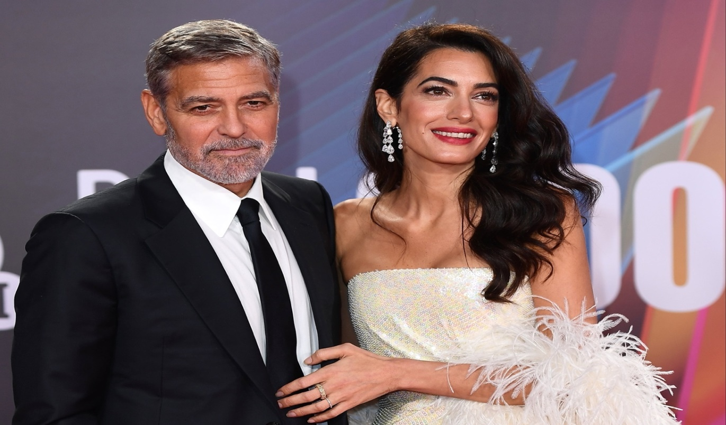

**GRAMMAR**

**Unit 1 The Gerund. The Infinitive**

**Exercise 1: Fill in the blanks with the correct form of the verb (gerund). Complete each sentence with the correct gerund form of the verb in parentheses.**

1. I enjoy ________ (read) books in my free time.
2. She is interested in ________ (learn) new languages.
3. They suggested ________ (go) for a walk after dinner.
4. He admitted ________ (make) a mistake during the presentation.
5. We are thinking about ________ (move) to a new city next year.
6. I’m looking forward to ________ (meet) you at the party tomorrow.
7. My brother hates ________ (wake) up early in the morning.
8. She is really good at ________ (play) the piano.
9. I prefer ________ (stay) at home on weekends rather than going out.
10. They are excited about ________ (travel) to Japan next summer.

**Exercise 2: Choose the correct gerund form of the verb to complete each sentence.**

1. I can’t stand (*to wait / waiting*) in long lines.
2. He is fond of (*to paint / painting*) landscapes.
3. We avoided (*to speak / speaking*) about politics at the dinner table.
4. They are planning (*to visit / visiting*) the museum this weekend.
5. I’m tired of (*to work / working*) so much.
6. She’s not used to (*to get / getting*) up so early.
7. We’re looking forward to (*to meet / meeting*) the new team members.
8. John is really interested in (*to learn / learning*) how to cook Italian food.
9. I prefer (*to swim / swimming*) in the ocean rather than in a pool.
10. He insists on (*to go / going*) to the concert even though he’s feeling sick.

**Exercise 3: Complete the sentences using a gerund.** Use the verbs in parentheses to form the correct gerund and complete each sentence.

1. I’m considering __________ (take) a gap year before university.
2. She regrets __________ (not study) harder for the exam.
3. My parents always encourage __________ (try) new things.
4. I’d love __________ (see) that new movie this weekend.
5. He can’t imagine __________ (live) in a small town.
6. They kept __________ (talk) during the movie, which was very annoying.
7. I don’t mind __________ (help) you with your homework.
8. It’s no use __________ (complain) about the situation.
9. The teacher suggested __________ (read) the chapter before the test.
10. I enjoy __________ (cook) new recipes on the weekend.

**Exercise 4: Gerund or Infinitive?** Some verbs are followed by either a gerund or an infinitive, but the meaning can change. Choose the correct form (gerund or infinitive) for each sentence.

1. I promised __________ (help) her with the project.
2. He offered __________ (take) us to the airport.
3. She refused __________ (leave) without saying goodbye.
4. They denied __________ (steal) the money.
5. I can’t afford __________ (buy) a new car right now.
6. He enjoys __________ (play) tennis every weekend.
7. I hope __________ (see) you soon.
8. We plan __________ (go) hiking next weekend.
9. The children love __________ (play) outside after school.
10. I can’t wait __________ (hear) the news!

**Exercise 5: Gerund as the subject.** In the following sentences, rewrite them by using a gerund as the subject of the sentence. (Example: “To swim in the ocean is amazing.” → “Swimming in the ocean is amazing.”)

1. It is important to exercise regularly.
2. It’s difficult to wake up early in the morning.
3. It’s enjoyable to travel to new places.
4. It’s impossible to avoid making mistakes.
5. It’s relaxing to read a good book on a rainy day.
6. It’s necessary to practice speaking English every day.
7. It’s boring to stay home all weekend.
8. It’s interesting to learn about different cultures.
9. It’s hard to say goodbye to good friends.
10. It’s dangerous to drive in bad weather conditions.

**Exercise 6: Sentence Transformation. Rewrite the sentences using the gerund form of the verb given.**

1. He is interested in learning how to play chess. (He wants...)
2. They suggested that we go to the beach. (They suggested...)
3. I don’t like to get up early. (I don’t like...)
4. She loves to spend time with her family. (She loves...)
5. I regret not going to the party last night. (I regret...)
6. My mother prefers to cook dinner at home. (My mother prefers...)
7. I am thinking about taking a vacation next month. (I am thinking...)
8. He enjoys playing the guitar. (He enjoys...)
9. We are planning to study abroad next year. (We are planning...)
10. I’m looking forward to seeing the concert. (I’m looking forward...)

**Exercise 7: Gerund after Prepositions. Complete the sentences by adding the correct gerund form after the preposition.**

1. She is afraid of __________ (fly) in airplanes.
2. He apologized for __________ (be) late to the meeting.
3. They are tired of __________ (work) long hours.
4. We’re interested in __________ (join) the club.
5. She’s famous for __________ (sing) opera.
6. I’m sorry for __________ (interrupt) you during the presentation.
7. He is good at __________ (solve) problems.
8. I’m excited about __________ (travel) to Europe this summer.
9. She insisted on __________ (come) to the party, even though she was busy.
10. They congratulated us on __________ (win) the competition.

**UNIT 2 Past Modals**

### Exercise 1. Complete the sentences with the correct form of the verb in parentheses and the appropriate past modal (could have, should have, might have, would have, etc.).

1. She __________ (study) harder if she had known the test was going to be so difficult.
2. If I had seen the sign, I __________ (avoid) the accident.
3. We __________ (go) to the concert, but we didn’t buy tickets in time.
4. They __________ (help) us if we had asked them for assistance.
5. He __________ (call) me yesterday to let me know he was running late, but he forgot.
6. I __________ (not eat) so much if I had known how full I was going to feel.
7. She __________ (tell) me about the surprise party, but she wanted to keep it a secret.
8. You __________ (finish) your homework last night instead of watching TV.
9. If they had known it was your birthday, they __________ (bring) you a gift.
10. I __________ (not be) so tired if I had gone to bed earlier last night.

### Exercise 2. ****Complete the Sentences with the Correct Past Modal.**** Fill in the blanks with the correct past modal (could have, should have, would have, might have, must have).

* She _______ (arrive) earlier to avoid the rush hour.
* They _______ (tell) me they were coming, but they didn’t.
* I _______ (study) more for the exam. I didn’t do well.
* He _______ (lose) his keys again; I saw him searching for them just now.
* We _______ (go) to the beach, but it started raining.

### Exercise 3. ****Error Correction.**** Find and correct the mistakes in these sentences.

* She should have to bring her homework yesterday.
* I could have finished the project, but I ran out of time.
* He must have forgetting his phone at home.
* They might have be waiting for us at the café.
* We shouldn’t have go to that party last night.

### Exercise 4. ****Fill in the Past Modal Based on the Situation.**** Write a past modal verb (*could have, should have, would have, might have, must have*) based on the situation.

1. You were invited to a party but didn’t go.

**Sentence**: I _______ (go) to the party, but I was too tired.

1. You are talking about an accident that happened, and you think someone could have avoided it.

**Sentence**: He _______ (drive) more carefully to avoid the crash.

1. A friend didn’t bring their homework to class.

**Sentence**: You _______ (remember) to bring your homework to class.

### Exercise 5. ****Past Modals in a Story.**** Write a short story about a time when you could have made a better decision. Use at least 3 different past modals in your story.

### For example: Last week, I _______ (take) the bus instead of driving to avoid the traffic. I _______ (realize) that I was running late, but I didn’t leave early enough.

### Exercise 6. ****Choose the Correct Past Modal.**** Choose the correct past modal to complete the sentence.

* He _______ (should have / must have) been more careful while handling the fragile vase.
* I _______ (could have / might have) finished the assignment if I had started earlier.
* They _______ (should have / would have) called us to let us know they were coming.
* You _______ (must have / could have) missed the bus if you were late.
* She _______ (might have / should have) known that she needed a passport to travel internationally.

**Exercise 7. Fill in modals:**

Dear Ms Walters,

Thank you for the email that you sent to my department yesterday. On behalf of the company, I________________________ to apologise for the mistake that we made with your order. When you received a delivery of fifty boxes of photocopier paper instead of the fifteen you actually ordered, this_________________________. I agree with you that we ________________________ to have noticed the error ourselves, and that ________________________sent you such an unusually large order without checking with you first.

I am afraid that so far I________________________find out what caused the mistake. Our sales assistant ________________________heard your order correctly on the telephone. Or there________________________been an error at our warehouse. In any case, I________________________investigate further in order to prevent this from happening again.

If you________________________kindly call my assistant on 4557 88888, we will arrange to collect the extra boxes at a time that is convenient for you. Once again,________________________offer my sincere apologies for our mistake.

Yours sincerely,

J. Barrington

Customer Service

**UNIT 3 Verbs of the Senses, Weak Form of “have”**

### ****Exercise 1. Verbs of the Senses Exercise. Complete the sentences with the correct verb of the senses** (*see, hear, smell, taste, feel*):**

1. I can **______** a strange noise coming from the kitchen.
2. I didn’t **______** her entering the room because I was too focused on my work.
3. When we were at the beach, I could **______** the salty air.
4. Can you **______** how soft this fabric is? It’s so smooth!
5. She didn’t **______** the new perfume I bought her. It was too strong.
6. I didn’t **______** anything unusual when I looked out the window.
7. My grandmother can no longer **______** very well, so she uses a hearing aid.
8. The soup is too salty; I can **______** it on my tongue.

**Fill in the blank with the correct form of the verb:**

1. I can’t **______** my keys anywhere. Have you seen them?
2. They didn’t **______** the crash, but they heard the sirens soon after.

### ****Exercise 2. Complete the sentences using the weak form of “have”:****

1. I **______** got a lot of work to do this weekend.
2. She **______** been to Paris before, but she’d love to go again.
3. We **______** seen that movie already.
4. They **______** finished their homework when I called them.
5. I don’t think they **______** much time to prepare for the presentation.
6. You **______** heard the news yet? It’s all over the internet.
7. They **______** a great time at the party last night.
8. He’s never **______** been to a concert.

**Rewrite the sentences using the weak form of “have” where appropriate:**

1. I have never been to this restaurant before.
2. She has to leave early today.

**Exercise 3. Fill in the appropriate verb:**

**Interview with a film director**

**Interviewer:**Can you tell me how you became a film director?

**Film director:**It_____________an easy process! When I left school I_____________no idea what I wanted to do, but I_____________always been interested in film so I decided I would go to film school, and I graduated three years later with a degree in film. But it took several years before I_____________enough funding to make a film.

**Interviewer:**Why_____________you want to be a film director?

**Film director:**I actually wanted to be a writer first._____________written three film scripts before I left college, but I now prefer directing, although I think I wouldn't have_____________such a good director if I_____________learned how to write first.

**Interviewer:**And you’ve got a new film coming out soon,_____________you?

**Film director:**Yes – I_____________finished it yet, but it_____________got an excellent cast and I'm very excited about it [3].

**GRAMMAR REVISION**

**Exercise 4. Open the bracket and use the correct tense form:**

The old man_____________(sit) in the doorway for hours, watching the endless commuters and shoppers walking by. Usually, no one ever_____________(stop) to speak to him or check that he was OK. He_____________(live) on the streets for the past five years, and_____________ (become) invisible to the majority of passers-by. He_____________(contemplate) moving off to the homeless shelter to get some breakfast when a shadow suddenly_____________ (loom) over him. Looking up, _____________(see) the angelic face of a young child peering at him through thick glasses. While he_____________ (stare) into the boy’s face, he_____________(become) aware of a strident voice admonishing the child: 'Come away from that filthy old man.' Somewhere in the depths of his muddled brain was a flicker of recognition. That voice! How could he forget it? The last time he_____________(hear) it was over 20 years ago when he_____________(leave) home five years before [4].

**Exercise 5. Put the words in the correct order and make sentences:**

* 1. Bahamas / for / years / she / lived / in / the / has

She_________________________________________________________.

* 1. quickly / puts / very / the first / of / paint on / layer / he

He__________________________________________________________.

* 1. they / exhibitions / the / have / city / frequently / cultural / in

They________________________________________________________.

* 1. her / by / strongly / other / been / work / modern artists / influenced / has

Her__________________________________________________________.

* 1. abstract / does / metal / mainly / sculptures / he / enormous

He___________________________________________________________[4].

**Exercise 6. Rewrite the second sentence. Use the words in brackets:**

* I haven’t seen him for two years (**since**)
* She didn’t want to go to the party, but she went anyway. (**although**)
* You must study harder to pass the exam. (**if**)

**videos**

**“How to Manage Your Emotions”**

* 1. **Answer the questions based on the video.**

**1.** How to manage your emotions according to the video?

**a.** to keep calm **b.** to recognize your emotions **c.** to simmer down

**2.** What’s the next stage?

**a.** to name emotions **b.** to suppress emotions **c.** to live them up

**3.** When we can name our emotions, they become less

**a.** haunting **b.** overwhelming **c.** enjoyable

**4.** The question: “What triggered this emotion?” helps us to:

**a.** to come to one’s senses **b.** to lose one’s temper **c.** pause & reflect

**5.** Rather than considering emotions as pitfalls, consider them as chances for

**a.** empathy **b.** self-love **c.** growth

**6.** Reframing helps you to:

**a.** look at emotions at a different angle **b.** let emotions control you

**7.** What can help you to feel grounded?

**a.** to bottle up emotions **b.**to express your emotions in a healthy way

**8.** How could a person find a peace of mind?

**a.** by expressing emotions thoughtfully **b.** by going off the deep end

**9.** Emotions are closely tied to:

**a.** physical well-being **b.** nonchalance **c.** high cortisol levels

**10.** Practicing self-awareness can help you:

**a.** be in the moment **b.** detach from negative emotions **c.** a & b. [https://ed.ted.com/lessons/how-to-manage-your-emotions]

**II.** **Emotion Labeling and Journaling**. **Goal:** Enhance self-awareness and emotional intelligence.

* **Instructions:** Reflect on a situation where you have experienced strong emotions (e.g., anger, sadness, anxiety, joy).
* **Steps:**
  1. Write down the situation that triggered the emotion.
  2. Label the emotion(s) you felt. Try to be specific (e.g., frustration vs. anger, disappointment vs. sadness).
  3. Identify where you felt this emotion in your body (e.g., tight chest, tense shoulders).
  4. Reflect on the thought patterns that accompanied the emotion (e.g., “This isn’t fair” or “I can’t handle this”).
  5. Record how you managed or reacted to the emotion at the time.
  6. Reflect on what you could do differently to manage similar emotions in the future.

**Discussion Prompt:** *After completing the exercise, discuss common emotional triggers and how they can be managed more effectively*.

**III.Emotion Regulation Techniques: Practice Deep Breathing. Goal:** Learn to use physical techniques to regulate emotional responses.

* **Instructions:**
  1. Start by sitting in a comfortable position, with your feet flat on the floor and your hands resting on your lap.
  2. Close your eyes and begin taking slow, deep breaths in through your nose, holding for a count of 4, and then exhaling slowly through your mouth for a count of 6.
  3. As you breathe, try to focus on your breath and let go of any racing thoughts. If your mind wanders, gently guide your attention back to your breathing.
  4. Practice for 3–5 minutes. Afterward, rate how calm or focused you feel on a scale from 1 to 10.

**Discussion Prompt:** *How did deep breathing impact your emotional state? Are there other emotional regulation techniques you already use or are interested in trying?*

**IV. The “Thought, Emotion, Action” Triangle. Goal:** Understand the connection between thoughts, emotions, and actions.

* **Instructions:**
  1. Draw a triangle on a piece of paper and label the three corners: *Thought*, *Emotion*, and *Action*.
  2. In each section of the triangle, write down an example of how each element connects:
     + *Thought:* What thought led to the emotion? (e.g., “I’m not good enough”)
     + *Emotion:* What emotion did the thought trigger? (e.g., anxiety, sadness)
     + *Action:* How did you behave as a result? (e.g., withdrawing, procrastinating)
  3. Reflect on whether the action was helpful or unhelpful in managing the emotion.
  4. Now, think of a more balanced or positive thought that could change the emotional response. How could you alter your behavior in response to this new thought?

**Discussion Prompt:** *How can altering your thoughts change the way you feel and act? Can you think of an example where changing your thought patterns helped you manage emotions better?*

**“How to Argue”**

* 1. **Watch the video and answer the following questions**:

1. Who is Dan Shapiro?
2. What are the three core elements of a successful negotiation mentioned by Dan Shapiro?
3. According to Shapiro, how does empathy play a role in resolving conflicts?
4. What is the significance of understanding both "interests" and "positions" in a negotiation?
5. What are some of the emotional triggers that can affect the negotiation process?
6. How can having a BATNA help in improving your negotiation position?
7. Would you use in your near future the given information? Why? Why not?
   1. **In pairs or small groups, discuss the following topics. Use the concepts from the video to support your opinions:**
8. **Is it better to negotiate with a focus on your position or on the interests of both parties? Why?**
9. **Have you ever experienced a situation where emotions influenced the outcome of a negotiation? How could empathy have changed the result?**
10. **Why is it important to prepare a BATNA before entering into a negotiation? Can you think of a situation where a BATNA might not be necessary?**
11. Have you ever heard about ZOPA? Could you decipher the acronym?

### ****Reflection Writing.**** Write a short essay (150-200 words) on the following question:

* ***How can the negotiation strategies discussed by Dan Shapiro be applied in everyday life, both professionally and personally? Provide examples from your own experiences or hypothetical situations.***

**“Cillian Murphy: The 60 Minutes Interview”**

* 1. **Watch the interview with Cillian Murphy on “60 Minutes” and answer the following questions:**

1. What is Cillian Murphy’s approach to acting?
2. How does he prepare for a role? What methods does he use to get into character?
3. What does Murphy say about the emotional impact of his roles?
4. Why does he choose certain roles? Does he have a specific criteria for selecting them?
5. What does Murphy mention about the media attention he receives and how it affects his private life?

**Follow-up Discussion:**

* What do you think makes Cillian Murphy a successful actor based on the interview?
* How would you prepare for a role if you were an actor?

### In pairs or small groups, discuss the following questions. Make sure to express your opinions and support them with reasons.

1. **Is it important for actors to keep their private lives separate from their professional careers?**
2. **Do you agree with Cillian Murphy’s approach to acting, where he remains focused on the craft and avoids being too affected by the fame that comes with it?**
3. **Do you think the media should focus more on an actor's work or their personal life? Why?**

**Follow-up:**

* Present the main points from your discussion to the class.

### ****Writing Practice - Interview Analysis****

**Instructions:** Write a short essay (150-200 words) analyzing Cillian Murphy’s perspective on acting as presented in the interview. Focus on his approach to roles, preparation, and how he deals with fame.

**Guiding Questions:**

* What does Murphy believe makes a good actor?
* How does his approach differ from other actors you know about?
* What role does media attention play in his career?

**Look at the pictures and discuss the phenomena of memes:**

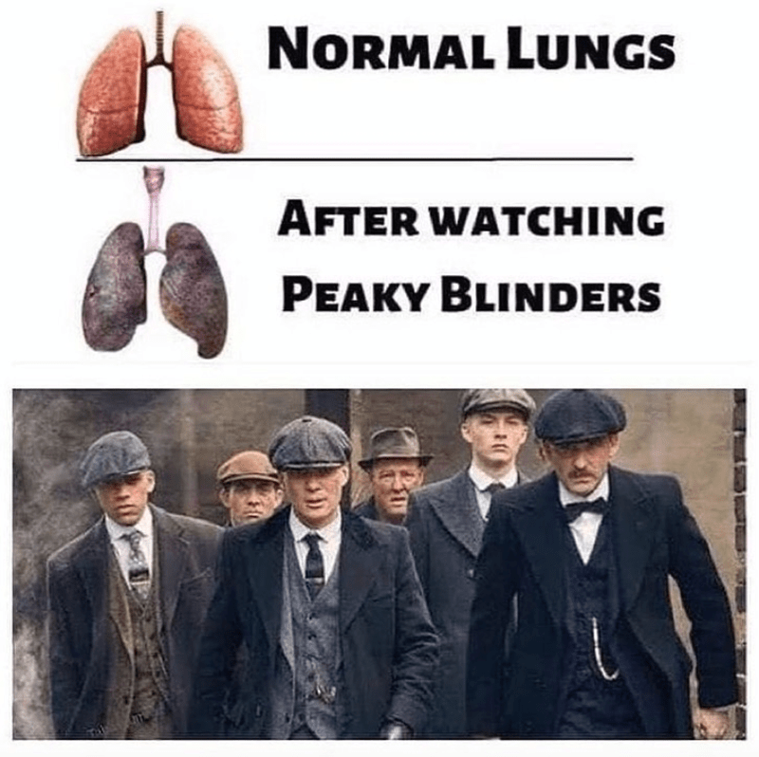

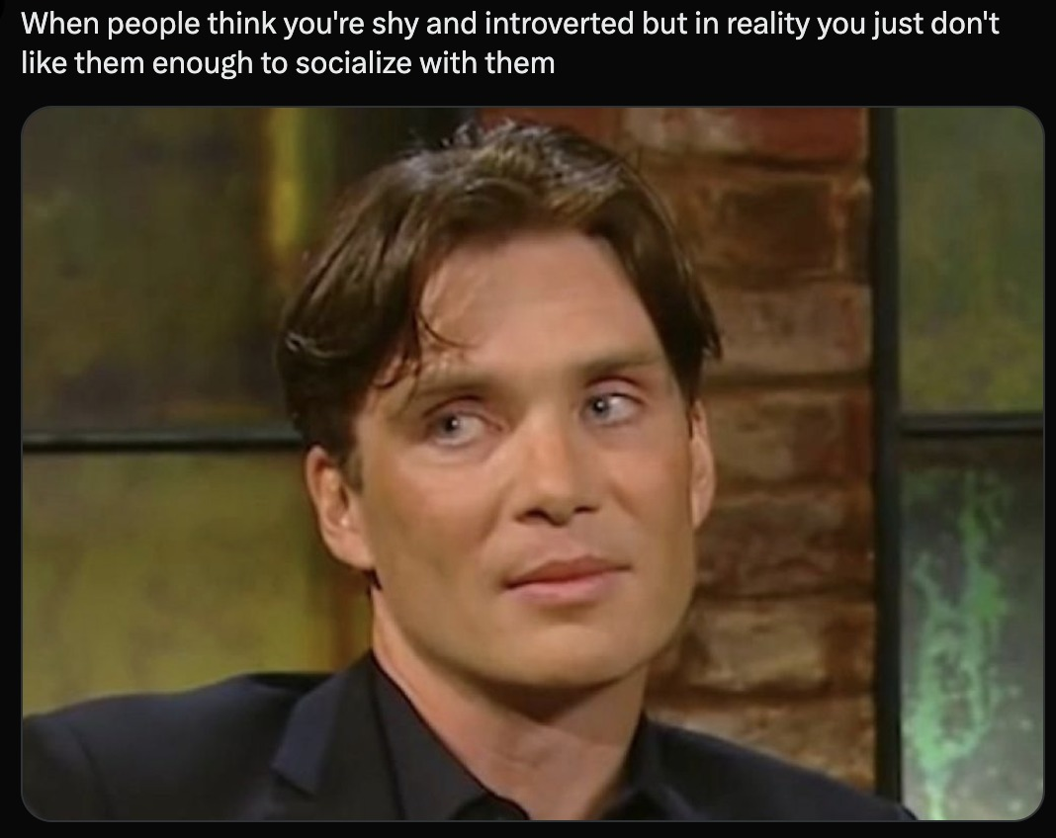

**WORDSEARCH**

**[6].** 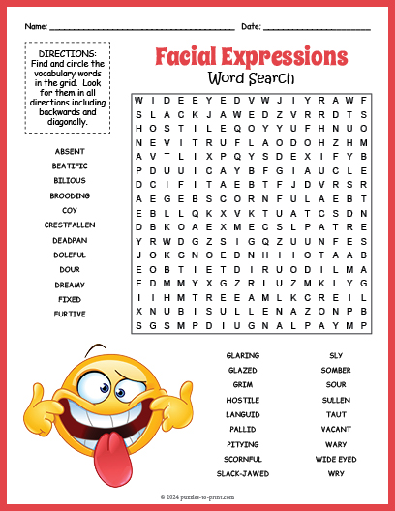

* 1. **Translate the unknown words and make a story.**
  2. **Describe a blogger/friend/celebrity using the words above.**

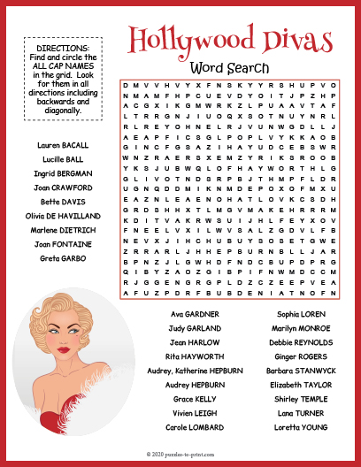**[7].**

1. **Choose one diva and prepare a presentation about life/career path.**
2. **Finish the sentence: One similarity/discrepancy is…..**

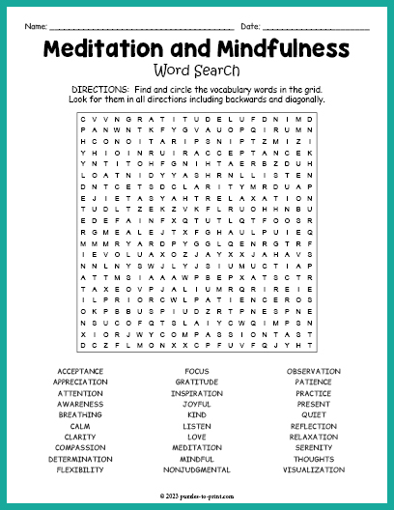

**[8].**

1. **Do you practice meditation? Why? Why not?**
2. **Make a list of things that elevate your mood.**

**References**

1. Bob Hastings High Note 4. – Pearson Education Ltd. – 2020. – 200 p.
2. Bob Hastings High Note 5. – Pearson Education Ltd. – 2020. – 189 p.
3. Mark Foley, Diane Hall My Grammar Lab Advanced C1/C2. – Pearson Education Limited. – 2025. – 410 p.
4. My English Lab. – Pearson Education Limited. – 2025.
5. https://www.examenglish.com/B2/b2_reading_music_uploaders.htm
6. <https://www.puzzles-to-print.com/health/facial-expressions-word-search.shtml>
7. <https://www.puzzles-to-print.com/printable-word-search/hollywood-divas-word-search.shtml>
8. <https://www.puzzles-to-print.com/health/meditation-and-mindfulness-word-search.shtml>
9. <https://www.youtube.com/watch?v=IDj1OBG5Tpw>

**Електронне навчально-методичне видання**

**Yuliya Talalay**

**Талалай Юлія**

**PRACTICAL ENGLISH LANGUAGE COURSE:**

**materials for self-study: a textbook for Master’s Degree students (Term 2)**

**ПРАКТИЧНИЙ КУРС АНГЛІЙСЬКОЇ МОВИ:**

**матеріали для самостійного опрацювання :** навчальний посібник для студентів другого магістерського рівня вищої освіти (2 семестр)

**Дрогобицький державний педагогічний**

**університет імені Івана Франка**

Редактор

*Ірина Невмержицька*

Технічний редактор

*Ірина Артимко*

Здано до набору 28.03.2025 р. Формат 60x90/16. Гарнітура Times. Ум. друк. арк. 3,75. Зам. 22.

Дрогобицький державний педагогічний університет імені Івана Франка. (Свідоцтво про внесення субʼєкта видавничої справи до державного реєстру видавців, виготівників та розповсюджувачів видавничої продукції ДК № 5140 від 01.07.2016 р.). 82100, Дрогобич, вул. Івана Франка, 24, к. 203.